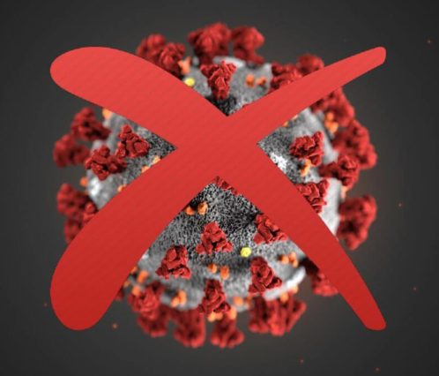
Stay Healthy
LSBA

Help prevent the spread of COVID-19.

KITCHEN
CLOSED

